- To identify directory or file
D starts with Directory
- start with file
How to add directory, file and change the permission
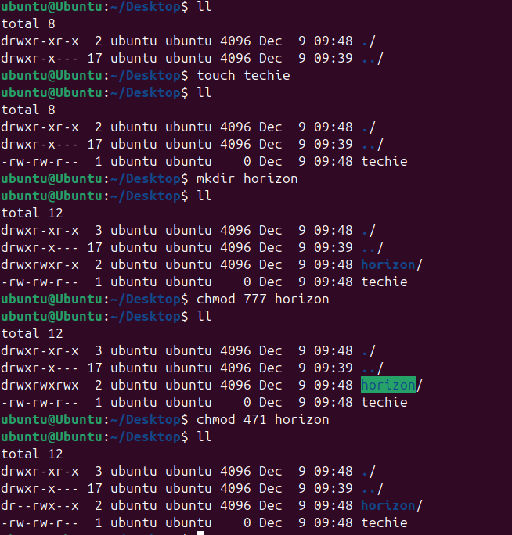
- List of available users in the group
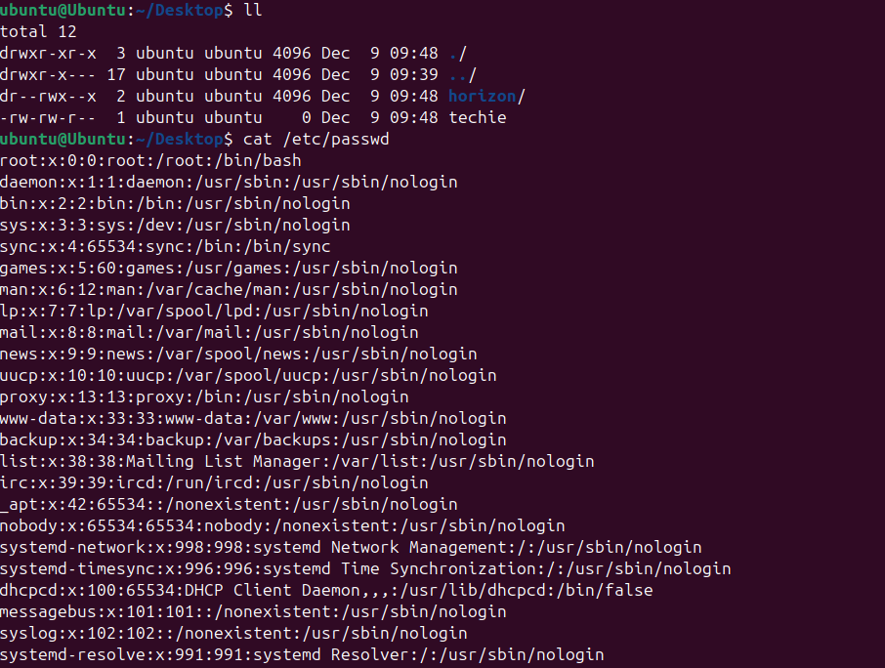
- Ownership change
Sudo – super user do
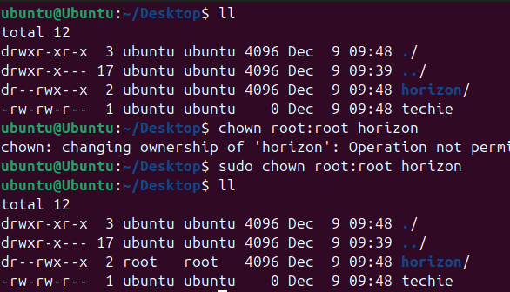
- Switch user Ubuntu to root to install the git
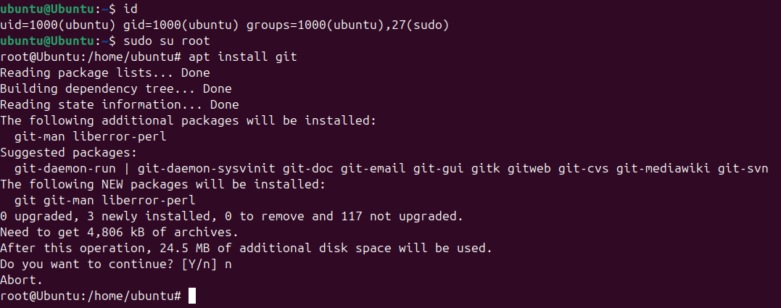
- To add new user and generate the password for new user and exit the user
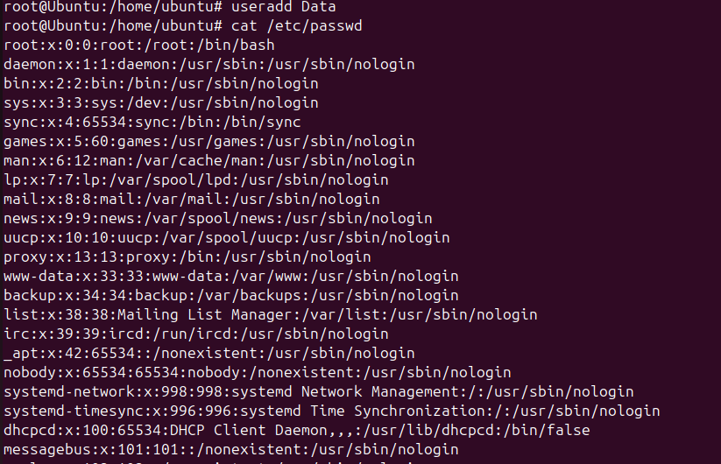
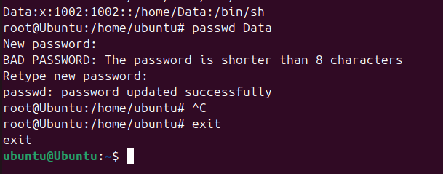
- To add new user in sudo
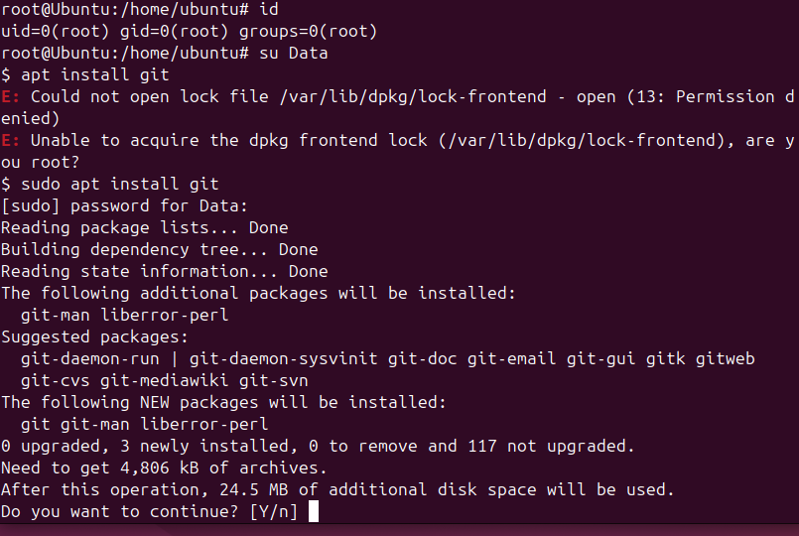
Echo
Single redirections
Double redirections
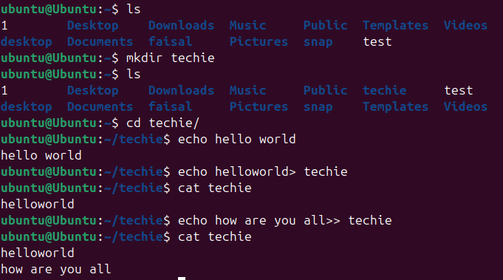
- Head
Tail
Tail –f to continuously monitor a file and ctrl+c to exit the new file
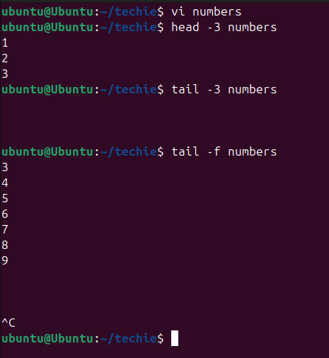
- To find file using txt document
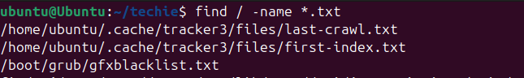
- To check the file which is older than 30 days
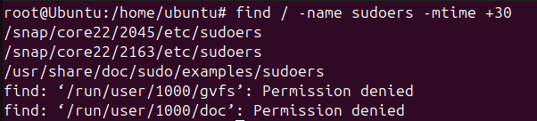
- To find specific key word or letter in file
-i parameter called to find capital or small
